EXPERIMENT 1:
Create a Kanban Board to Visualize the Tasks.
1) Create Columns for To Do, In-Progress and Done.
2)Add Atleast 5 Sample Tasks
3) Move the Tasks across the Columns to Simulate the Workflow.
STEP 1: LOGIN
- Open a web browser and navigate to the Jira website.
- Login - https://id.atlassian.com/login
- Sign in to your Jira account using your registered email address and password.
- After successful authentication, access the Jira dashboard to begin the project creation process.
STEP 2: CREATE THE KANBAN PROJECT
- Click the Create Project option from the Jira dashboard.
- Select the Kanban project template to create a workflow-based project.
- Enter the project details, including the project name "Task Management Board", choose Team-managed as the project type, keep the access as Open, and provide a project key.
- Click Next to continue with the project setup.
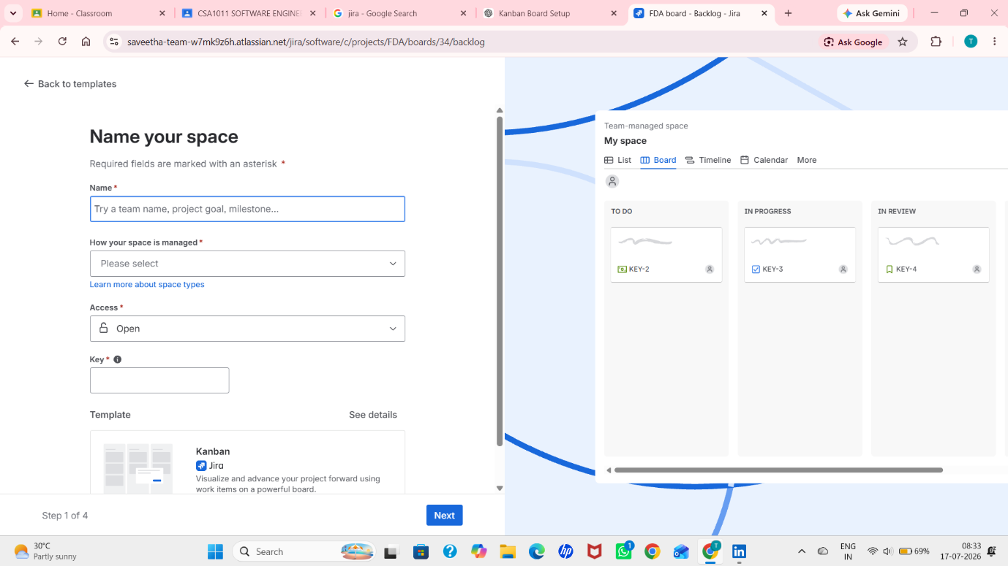
STEP 3: CONFIGURE THE PROJECT SETTINGS
- Review the default Work Types, including Epic, Feature, Task, Story, and Bug.
- Verify the default workflow statuses such as To Do, In Progress, In Review, and Done.
- Review the available project views, including Summary, List, Board, Calendar, Timeline, Pages, and Forms.
- Keep the Start with sample work items option disabled and click Next to complete the configuration.
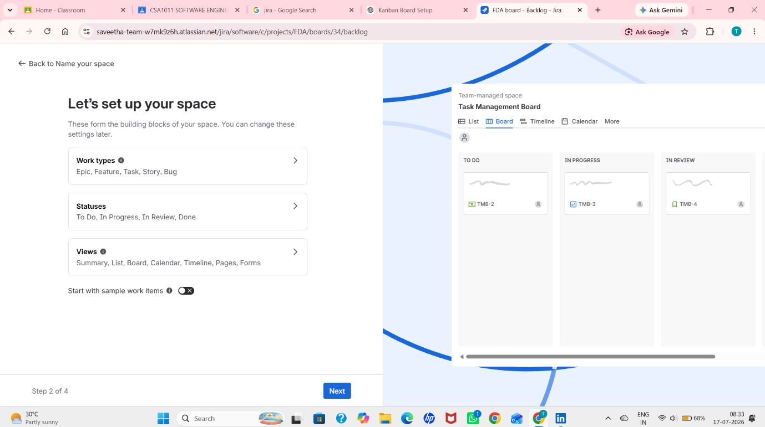
STEP 4: ADD TASKS TO BACKLOG
- Open the Backlog tab in the Kanban project to create and manage project tasks.
- Click the Create button to add new work items to the backlog.
- Create the required tasks, namely Restaurant Listing, Add Food to Cart, User Registration, Payment Integration, Design Login Page, Collect Project Requirements, and Design UI Mockups.
- Assign the appropriate status to each task based on the project workflow.
- Verify that the created tasks are successfully displayed in the Backlog, with completed and active tasks shown according to their current workflow status.
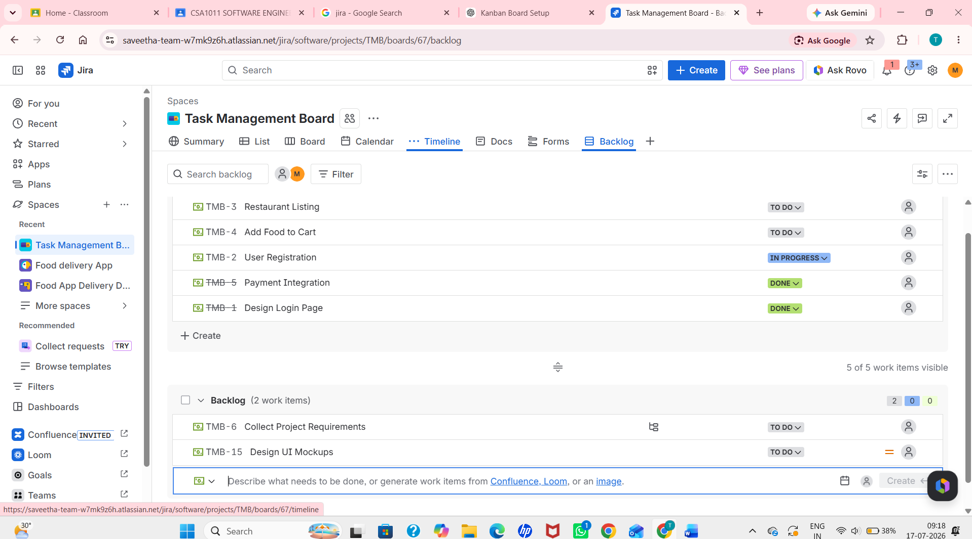

STEP 5: CREATE ISSUES (TASKS)
- Open the newly created Kanban Board and navigate to the To Do column.
- Create the required project tasks by adding the following issues: Restaurant Listing, User Registration, Add Food to Cart, Design Login Page, and Payment Integration.
- Verify that all five tasks are successfully created and displayed in the To Do column of the Kanban board.
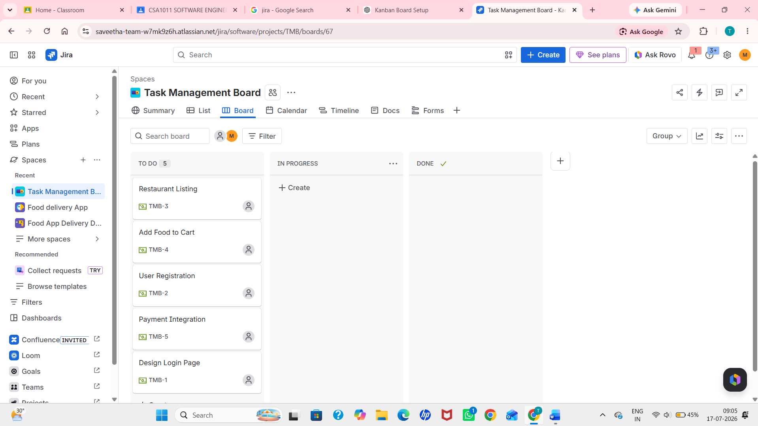

STEP 6: MOVE ISSUES ACROSS THE WORKFLOW
- Simulate the project workflow by dragging the created tasks to different workflow stages.
- Move User Registration from To Do to In Progress.
- Move Design Login Page from To Do to In Review.
- Move Payment Integration from To Do to Done.
- Keep Restaurant Listing and Add Food to Cart in the To Do column to represent pending tasks.
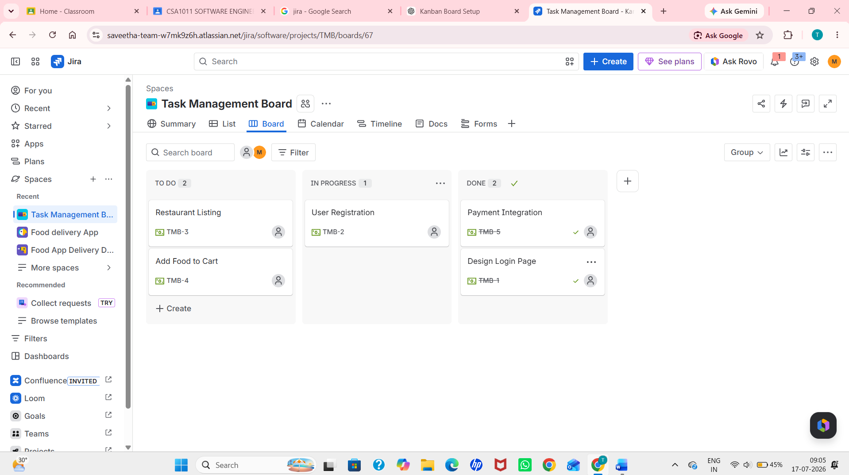

STEP 7: FINAL WORKFLOW SIMULATION
- Complete the workflow simulation by moving Design Login Page from In Review to Done.
- Keep User Registration in the In Progress column to indicate that the task is currently under development.
- Leave Restaurant Listing and Add Food to Cart in the To Do column to represent tasks that have not yet been started.
- Ensure that Payment Integration remains in the Done column, indicating that the task has been successfully completed.
- Verify that the Kanban board clearly displays the movement of tasks across the To Do, In Progress, and Done stages, demonstrating the complete workflow of the project.

